**Experiment – 02**

**AIM**: To create a basic tags application, a web document which should have headings,

subheadings, paragraphs, lists, images and to explore new tags to complete the experiment.

**The Basic Tags.**

* **<!DOCTYPE>**Declaration: It is not an HTML tag. It is an instruction to the web

browser about what version of HTML the page is written in.

* **<html>** Tag-The HTML document itself begins with <html> and ends with </html>.
* **<head>** Tag-HTML <head> tag is a Container Tag. All Header element contains like general information about page, meta-information, style sheet URL and document type information.
* **<body>** Tag-HTML body section is a main contain section of web page all contain that will be seen when the user loads the webpage.
* **<title>** Tag-The <title> tag is required in all HTML documents and it defines the title of the document.
* **<center>** Tag-It is used to center-align text.
* **<font>** Tag-It specifies the font face, font size, and color of text.
* **<b>** Tag-It specifies bold text.
* **<i>** Tag-Its content is displayed in italic.
* **<u>** Tag-It underlines the text.
* **<br>** Tag-It is an empty tag which means that it has no end tag and it inserts a single line break.
* **<ol>** Tag-It defines an ordered list and it can be numerical or alphabetical.
* **<li>** Tag-It defines a list item. The <li> tag is used in ordered lists(<ol>), unordered lists

**<ul>**and in menu lists (<menu>).

* **<a>** Tag- It defines a hyperlink, which is used to link from one page to another.
* **<img>** Tag- It defines an image in an HTML page.
* **<p>** Tag-The <p> tag defines a paragraph.
* **<div>** Tag-The <div> tag defines a division or a section in an HTML document. The <div>

tag is used to group block-elements to format them with CSS.

* **<ul>** Tag-The <ul> tag defines an unordered (bulleted) list. We can use the <ul> tag

together with the <li> tag to create unordered lists.

* **<h1>...<h6>** Tags-HTML header tag h1 is used for specifying heading level 1. There are 6

levels of headings (h1 - h6) with h1 the most important and h6 the least important.

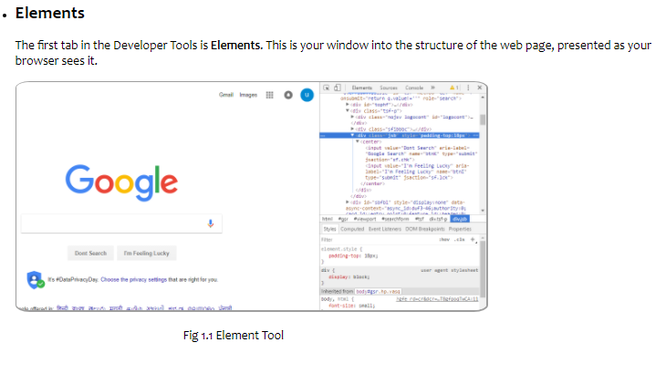

**Fig 2.1.1: Element Tool**

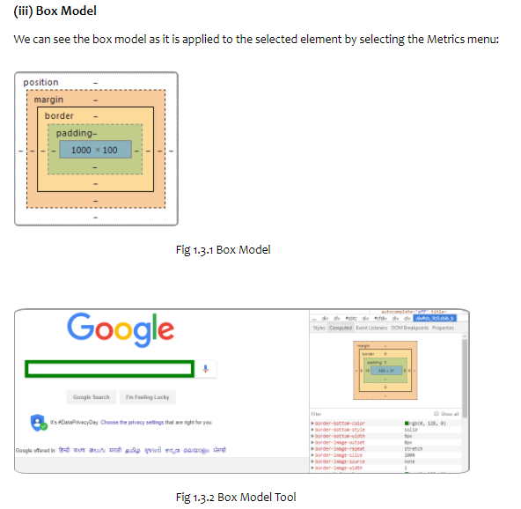

**Fig 2.1.2: Box Model**

**Code Snippet:**

**<!—Elements Panel-->**

<li><h2 style=" font-family:Candara;">Elements</h2>

<p class="para">The first tab in the Developer Tools is <b>Elements</b>.

This is your window into the structure of the web page…

</p>

<img class="img_style" src="images/elemnt dom.png" >

<p class="para" style="margin-left: 25%"> Fig 1.1 Element Tool</p>

<br><br>

<h3 style=" font-family:Candara;">(i) DOM Browsing</h3>

<p class="para">

The Elements tab is better than "View Source" for a Page…

</p>

<br><br>

<h3 style=" font-family:Candara;">(ii) Styles Browsing</h3>

<p class="para">The cascading nature of CSS makes the Styles browser in the Elements tab very useful…

</p>

<br>

<img class="img_style" src="images/style.png" >

<p class="para" style="margin-left: 25%">Fig 1.2 Styling</p>

<br><br><br>

<h3 style=" font-family:Candara;">(iii) Box Model</h3>

<p class ="para">We can see the box model as it is applied to the selected element by selecting the Metrics menu:

</p>

<br>

<img style="text-align: center;border: 2px solid #9E9E9E;border-radius: 3%; width: 25%" src="images/Sketch2.png">

<p class="para" style="margin-left: 25%">Fig 1.3.1 Box Model</p>

<br><br><br>

<img class="img_style" src="images/box.png" >

<p class="para" style="margin-left: 25%">Fig 1.3.2 Box Model Tool</p>

</p>

</li>

**<!—Console Panel -->**

<li> <h2 style=" font-family:Candara;">Console</h2>

<br>

<img class="img_style" src="images/Sketch3.png" >

<p class="para" style="margin-left: 25%">Fig 2.1 DevTools Console</p>

<p class="para">We can access the Console as a full-screen …

<ul style=" font-family:Candara;">

<li>Press Ctrl+Shift+J (Windows / Linux) or Cmd+Opt+J (Mac).</li>

<li>If DevTools is already open, press the Console button.</li>

</ul>

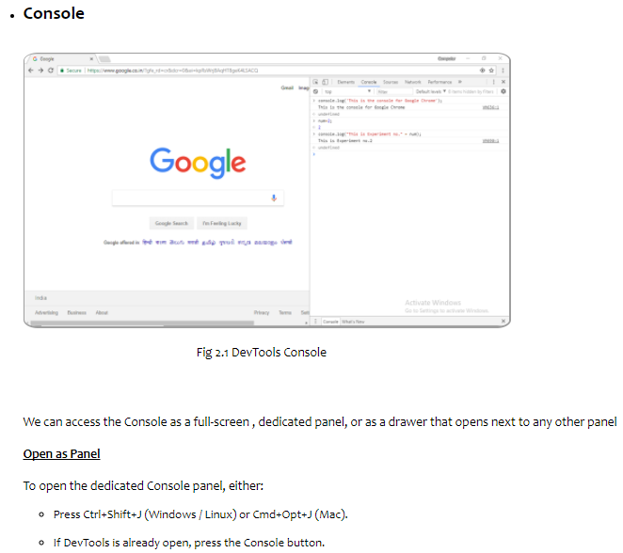

**Fig 2.2: Console panel**

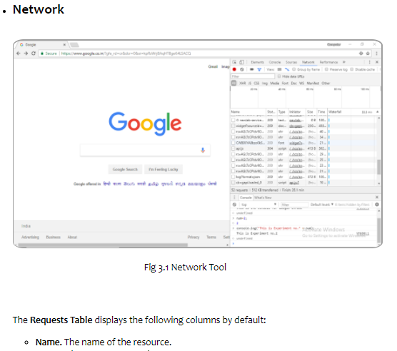

**Fig 2.3: Network panel**

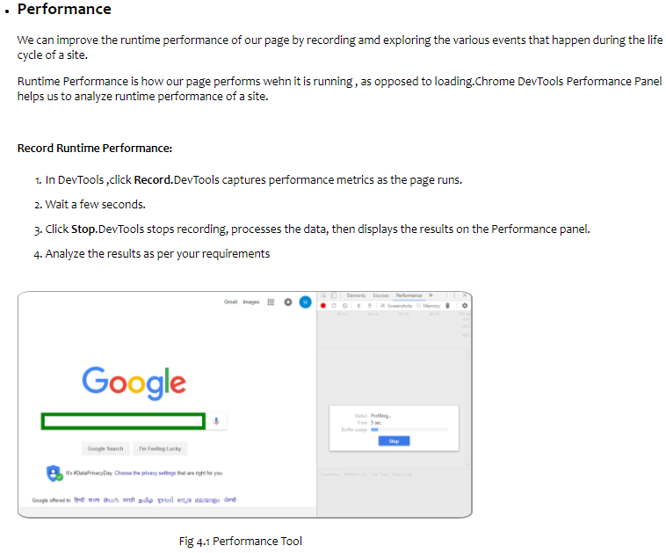

**Fig 2.4: Performance panel**

<br><span style="text-decoration:underline; font-weight: bolder; font-family:Candara;"> Open as drawer</span><br><br>

To open the Console as a drawer next to any other panel, either:<br>

<ul style=" font-family:Candara;">

<li>Press Esc while DevTools is in focus.</li>

<li>Press the Customize and control DevTools button and then press Show console.</li>

</ul></p></li>

**<!—Network Panel -->**

<li><h2 style=" font-family:Candara;">Network</h2>

<br>

<img class="img_style" src="images/Sketch4.png">

<p class="para" style="margin-left: 25%">Fig 3.1 Network Tool</p>

<br><br>

<p class="para">

The <b>Requests Table</b> displays the following columns by default:<br>

<ul style="font-size: 17px; font-family:Candara;">

<li><b>Name.</b> The name of the resource.</li>

<li><b>Status.</b> The HTTP status code.</li>

<li><b>Type.</b> The MIME type of the requested resource.</li>

<li><b>Initiator.</b> The object or process that initiated the request.</li>

<li><b>Parser.</b> Chrome's HTML parser initiated the request.</li>

<li><b>Redirect.</b> An HTTP redirect initiated the request.</li>

<li><b>Script.</b> A script initiated the request.</li>

<li><b>Other.</b> Some other process or action initiated the request..</li>

<li><b>Size.</b> The combined size of the response headers.</li>

</ul> </p></li>

**<!—Performance Panel -->**

<li> <h2 style=" font-family:Candara;">Performance</h2>

<p class="para">We can improve the runtime performance of our page by recording amd exploring the various events that happen during the life cycle of a site. </p>

<p class="para">Runtime Performance is how our page performs wehn it is running , as opposed to loading.Chrome DevTools Performance Panel helps us to analyze. </p>

<p class="para"><b>Record Runtime Performance:</b></p>

<p>

<ol style="line-height: 35px; font-size: 17px; font-family:Candara;">

<li>In DevTools ,click <b>Record.</b>DevTools captures performance metrics as the page runs.</li>

<li>Wait a few seconds.</li>

<li>Analyze the results as per your requirements</li></ol> </p>

<img class="img_style" src="images/performance.png" >

<p class="para" style="margin-left: 25%">Fig 4.1 Performance Tool</p>

</li>